**Student Management System (SMS)**

A Minor Project Synopsis Report

Submitted in Partial Fulfilment of the Requirement for the Award of Degree of

**BACHELOR OF TECHNOLOGY**

**(COMPUTER SCIENCE AND ENGINEERING)**

To



**UTTARAKHAND TECHNICAL UNIVERSITY, DEHRADUN**

Submitted by

**Ankit Raj (180410101012)**

**Shantanu Paul (180410101044)**



**Shivalik College of Engineering**

**Dehradun, Uttarakhand**

|  |  |  |  |  |  |  |  |  |  |  |  |  |  |  |  |  |  |  |  |  |  |  |  |  |  |  |  |  |  |  |  |  |  |  |  |  |
| --- | --- | --- | --- | --- | --- | --- | --- | --- | --- | --- | --- | --- | --- | --- | --- | --- | --- | --- | --- | --- | --- | --- | --- | --- | --- | --- | --- | --- | --- | --- | --- | --- | --- | --- | --- | --- |
| **Minor Project Synopsis**   |  |  |  | | --- | --- | --- | | **Faculty Use only:** | | | | **Selected / Rejected** | **Name of the Guide** | **Name of the Project coordinator** | |  |  |  |   ----------------------------------------------------------------------------------------------------------------------------------------   |  | | --- | | **1. Mini Project Topic / Title: Online Quiz Portal** | | Tentative: | | Finalized (Guide will write): |  |  |  |  |  |  |  | | --- | --- | --- | --- | --- | --- | | **2. Details of Group Member:** | | | | | | | **Roll. No.** | **Course** | **Stream** | **Name of Student** | **Mobile Number** | **Email Id** | | 180410101012 | B.Tech | CSE 3rd | Ankit Raj | 7352372491 | ankitrajrks.cse@sce.org.in | | 180410101044 | B.Tech | CSE 3rd | Shantanu Paul | 7017346198 | shantanupaulscp.cse@sce.org.in | |
| **Project Overview/Background:**  Introduction**: *"***Student Management System (SMS) is a solution tool that is designed to track, maintain and manage all the data generated by a School, including the grades of a student, their attendance, their interpersonal activities records, etc.,"  SMS acts as the bottom-line database to store all the day-to-day school operations, maintain the proper records of the past few decades, regulate the various operation modules, managing the critical tasks, efficiently handling the administrative processes such as:  1. Admissions  The Student Management System software is created to help manage the student's admissions activities, starting from initial communication to course enrolment.  2. Billing and Payments  The Payments paid or received can also be managed and recorded through Student Management System; unlike invoice generation, credit notes, refunds, etc., SMS stores all the necessary information about parents and staff suppliers, and contractors.  3. Reporting  Reporting feature benefits the schools to analyze the trends in student behavior and examine the outcomes to boost their performance.  4. Tracking Student's Fees  Fee tracking is one of the most beneficial features of this online software.  The school administration department can track billing dates, induce late fee penalty, generate invoice, and automatically gets the report of received payments throughout the year.  Student Management System software is helpful for teachers and school supervisors and also support applications and dashboards effective for students and parents as well for communication and combined data collection.  The other names of Student Management System are Student Information System (SIS), Student Information Management System (SIMS) and Student Record System (SRS). |

Need of Work / Reason for selection of this project:

### 1. Enhances the overall Performance of Students

One of the mantras to improve academic performance is by constantly monitoring your pace. Therefore, with the help of school administration software, the students utilize their time on studies and all the other tasks, unlike keeping track of their performance; maintaining records all are handled by SMS software.

### 2. It helps to Streamline all Task

Because of its efficient dashboard, teachers can easily maintain, monitor, track the performance of every student, and eventually take appropriate measures to get it completed.

### 3. Improved Communication

During a physical batch, whenever a teacher delivers any lesson, it is likely that some students won't catch the lesson perfectly and may have their doubts. But with such strength, it becomes impossible for students to clear their problems.

Also, some students are introvert in nature and may feel shy to ask things in front of the class. SMS has been designed in such a way so it can cater to the above issues. Most software has inbuilt discussion portals allowing students to communicate with their teachers and clear their doubts.

### 5. Well-organized Management and Organization of Programs

The timetable of a class is organized by the school admin department and passed across to teachers and students. Despite being committed to their responsibility, it never relates, and there is always a clash of lectures. With this software, the admin department freezes the timetable online, preventing all the clash errors. In addition to that, every party, including students, teachers, and parents, can easily access it.

### 6. Helps to maintain the record of All Students

Not only academics, School monitors the overall personality grooming, including **sports, recitation, music, dance, aerobics, swimming, etc**. Software Management System keeps a proper track and documentation of extracurricular activities, making sure that the record of every student is intact.

Objective: The cost and time invested in employing staff to direct all the School's day-to- day events is an extra cost that could be easily cut down by implementing this new open-source administration management technology. It also decreases the usage of written materials, human errors, and staff workload.

Earlier it was too challenging for teachers to keep track of all the activities and tasks allocated to each student, and sometimes it gets overlooked. But life has become easy with the **school management software**. Because of its efficient dashboard, teachers can easily maintain, monitor, track the performance of every student, and eventually take appropriate measures to get it completed.

Problem Statement (explain what you want to implement in this project in

short sentence):

* A student management system (also known as a student information system or SIS) helps a school manage data, communications, and scheduling. A school system generates and uses a large amount of data. This data must be communicated appropriately to students, faculty, and parents. A student management system helps schools to store, manage, and distribute this information.
* Some student management systems are designed to serve all of a school’s student data management needs. Other student management systems are specialized. These specialized solutions target specific needs, such as school applications or student behavior tracking.
* Student management systems provide many benefits to educational institutions, mostly stemming from centralized data management and accessibility. Teachers can more easily input, manage, and access student data. Parental guardians get better visibility into how their student is performing in classes. State-level compliance and other regulatory requirements are also much easier to fulfil.

Block diagram with explanation:

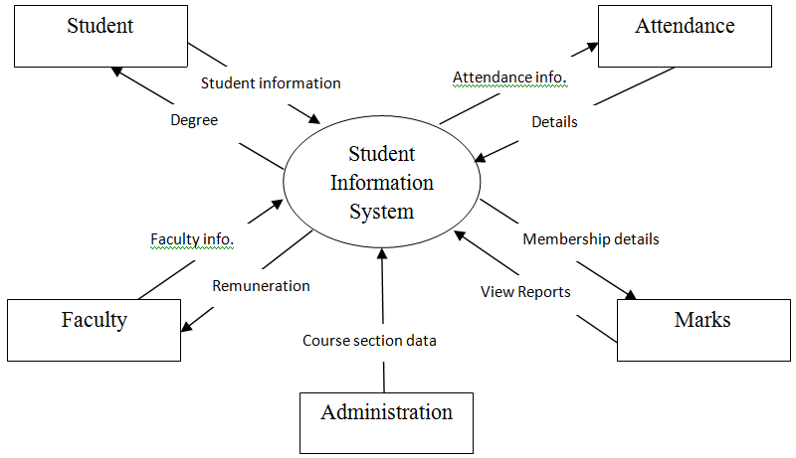

Benefits to the surrounding/society:

## 1: Increases Productivity

The [**school management information system**](https://www.iitms.co.in/blog/role-of-management-information-system-in-education.html) boosts the productivity of the institute. The reason for the increase in productivity is decreased time to maintain the track records and increased accuracy in organizing the data. Less time leads to keeping the institute focused on the productivity of the school.

## 2: Best Student-Teacher Collaboration

Using the cloud-based school ERP leads to student-teacher collaboration beyond the classroom. This increases the interaction between the staff and the students. The interaction happens over the application (online) where the teacher is available to answer queries of the students. It also facilitates a friendly atmosphere in academics.

## 3: Saves Natural Resources

Stationary right from the paper files to records is saved when the ERP system is used for performing routine administrative tasks. It leads to saving the natural resources and keeps a digital track of the data. Also, it does not create a mess of the records to be maintained.

## 4: Access From Anywhere

The software can be accessed from anywhere and at any time. A record of everything can be kept due to its easy accessibility. It also facilitates providing immediate information to all the stakeholders. All they require is the credentials of the online education ERP portal.

## 5: Increase In Student Enrollment Ratio

Due to the hectic schedule of the organizations and the tough decision-making policies, it becomes troublesome to check in with the enrollment ratio of the students. It is thus required to implement proper school software so as to reduce the burden from various activities. **Features of the school management system** such as **analytics dashboard & reports generation** lets the organization focus on increasing the students’ enrollment.

**Methodology:**

Proposed Techniques or methods to be implemented:

Language: Asp.net C#

Backend- Microsoft sql

Project Flowchart:

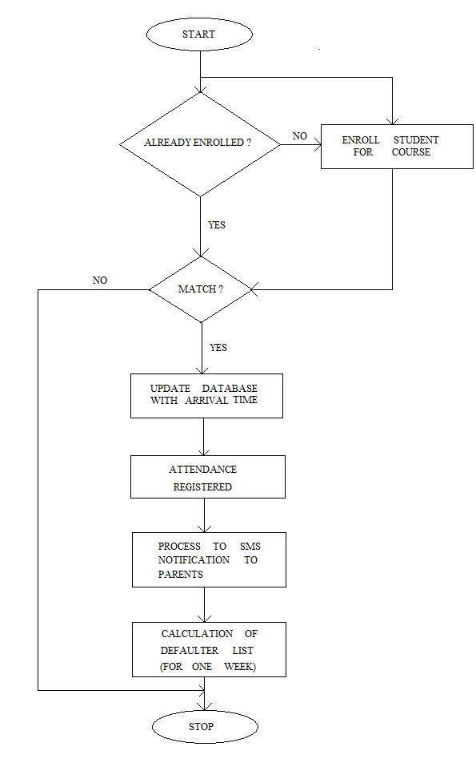

Advantages:

### **Better Performance by Students**

### **Simplifying & Streamlining all Tasks**

### **Better Communication**

### **Easy Access to All**

### **Complete Tracking of the Students**

### Limitations:

### The drawbacks in Student Management System software can be counted on fingers; with mostly only benefits, these systems have a few countable downsides. Often, applications face minor technical glitches and these systems are no exception but, ratification is immediate. Only, people who are accustomed to regular use of smartphones or computers can operate this software. Extensive modules and features make it difficult for a user to utilise the application. With huge flow in traffic the application is prone to performance issues. Few companies market their products at extravagant price, which are not affordable by growing organizations. Absence of proper internet-network makes it difficult for a user to access information, which is a significant disadvantage. The risk of data mishandling might be bothersome; but all these drawbacks can be evaded by choosing proper, cost-efficient and best software that best benefits an organization.

### Applications:

* [Hassle free recruitment/enrollment processes](https://www.creatrixcampus.com/blog/10-ultimate-benefits-student-information-system#blog-section1)
* [Managing student information](https://www.creatrixcampus.com/blog/10-ultimate-benefits-student-information-system#blog-section2)
* [Student portal](https://www.creatrixcampus.com/blog/10-ultimate-benefits-student-information-system#blog-section3)
* [Academic advising](https://www.creatrixcampus.com/blog/10-ultimate-benefits-student-information-system#blog-section4)
* [To foster efficiency](https://www.creatrixcampus.com/blog/10-ultimate-benefits-student-information-system#blog-section5)
* [Redundant human errors](https://www.creatrixcampus.com/blog/10-ultimate-benefits-student-information-system#blog-section6)
* [Parental portal](https://www.creatrixcampus.com/blog/10-ultimate-benefits-student-information-system#blog-section7)
* [No more data breaches](https://www.creatrixcampus.com/blog/10-ultimate-benefits-student-information-system#blog-section8)
* [Effortless communication](https://www.creatrixcampus.com/blog/10-ultimate-benefits-student-information-system#blog-section9)

### Project requirements:

### Equipments: A Computer with good internet connection and latest applications with proper functioning.

Facilities required (include software, hardware):

### • Microsoft .Net framework 3.5 • Microsoft Visual Studio 2008 • Microsoft ASP.Net 3.5 • Microsoft C#.Net language • Microsoft SQL Server 2005 • ADO.NET • HTML

Processor: Intel Pentium 4 or more

Ram: 1 GB or more

Hard disk: 40 GB hard disk recommended for the primary partition.

**References:**

<https://1000projects.org/software-requirements-specification-student-management-system.html>

<https://www.slideshare.net/amit_gandhi/references-35796171>

<https://www.academia.edu/34508514/IIMSR_STUDENT_MANAGEMENT_SYSTEM_A_PROJECT_REPORT>

<https://www.phptpoint.com/projects/student-management-system-project-in-codeigniter>

<https://www.lovelycoding.org/student-management-system/>

<https://www.javatpoint.com/fee-report-project-in-java>

<https://meeraacademy.com/student-management-system-project-asp-net/>

<https://www.sourcecodester.com/php/12060/student-management-system-php.html>

<https://projectworlds.in/student-information-system-project-report-synopsis-in-php/>

<https://www.scribd.com/doc/312637173/Project-Report-Student-Information-System>

<https://sites.google.com/site/ignoubcafinalyearprojects/project-report/student-information-management-system-project-report>

<https://cse.final-year-projects.in/a/2248-student-information-management-system-using-php-mysql.html>

Signature of Guide

Signature of Minor Project Co-ordinator :